**Configuring JDBC in TomEE**

## JDBC Configuration for the TomEE Server

If you wish to configure a JDBC driver for the entire TomEE server than you can add the <Resource> element directly under the <tomee> element of the tomee.xml file. Below is an example of a JDBC configuration for the Derby Embedded database.

<tomee>

<Resource id="Derby Database" type="DataSource">

JdbcDriver org.apache.derby.jdbc.EmbeddedDriver

JdbcUrl jdbc:derby:derbyDB;create=true

UserName admin

Password pass

</Resource>

</tomee>

The tomee.xml configuration file is located at <apache-tomee>/conf/tomee.xml as illustrated below.

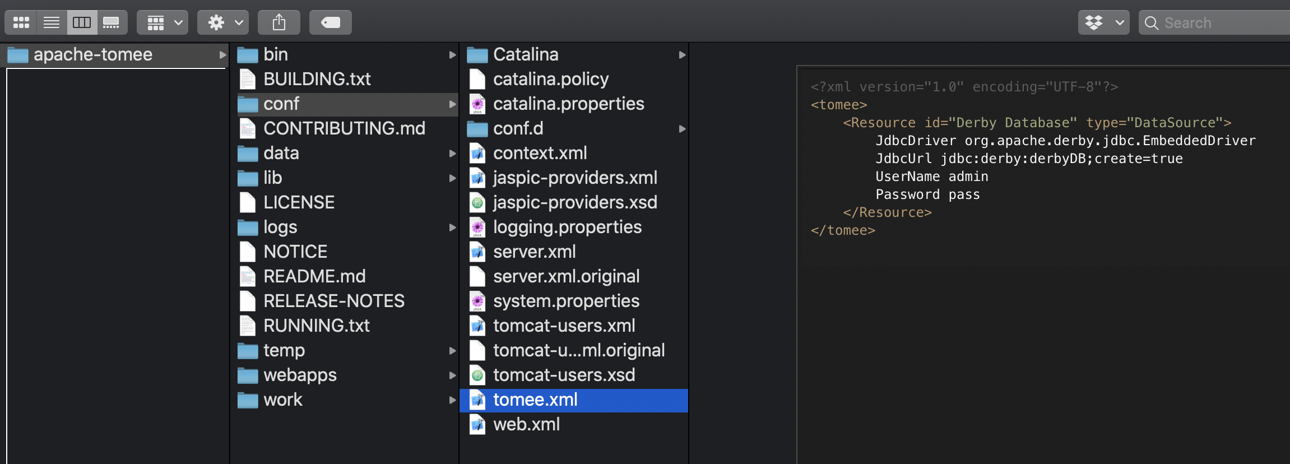

## JDBC Configuration for a Webapp in TomEE

If you wish to configure a JDBC driver for a specific webapp than you add the <Resource> element as the root of the resources.xml file like this.

<resources>

<Resource id="Derby Database" type="DataSource">

JdbcDriver org.apache.derby.jdbc.EmbeddedDriver

JdbcUrl jdbc:derby:derbyDB;create=true

UserName admin

Password pass

</Resource>

</resources>

The resources.xml file should be created and stored under the webapp/WEB-INF/resources.xml in the source file for you webapp as shown below so that when you package the webapp the resources.xml file is included for deployment.

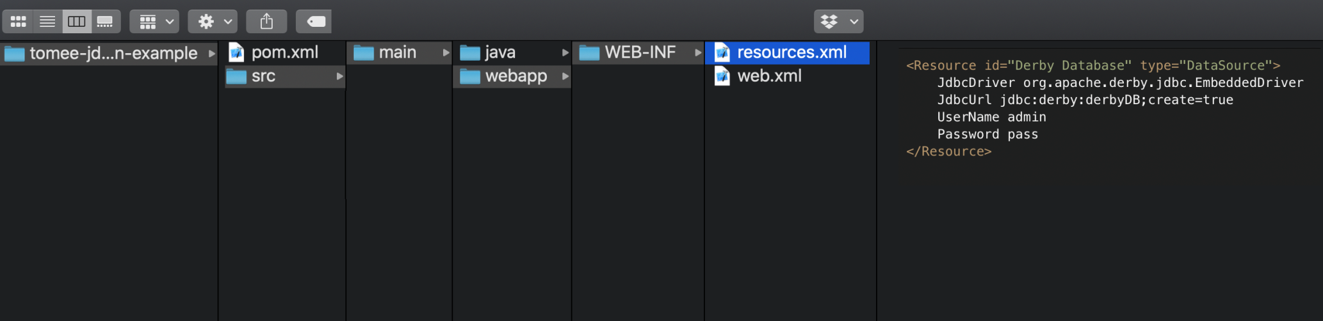

The declaration of a <Resource> in the resources.xml file will override any setting for the same <Resource> id in the tomee.xml file. In addition, you can set the TomEE system properties for a specific JDBC connection and that will take precedence over both the tomee.xml and the resources.xml configurations. More information can be found [here](http://tomee.apache.org/application-resources.html).